Walkthrough 13 Margins and Paddings

https://sapui5.hana.ondemand.com/#/topic/17b87fbafb5a4474982760d2a3a73e69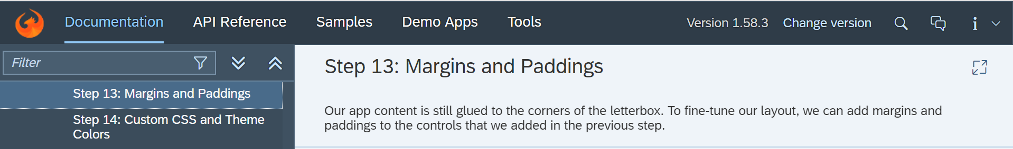

Core Changed Codes Compared to Last Version:

I18n

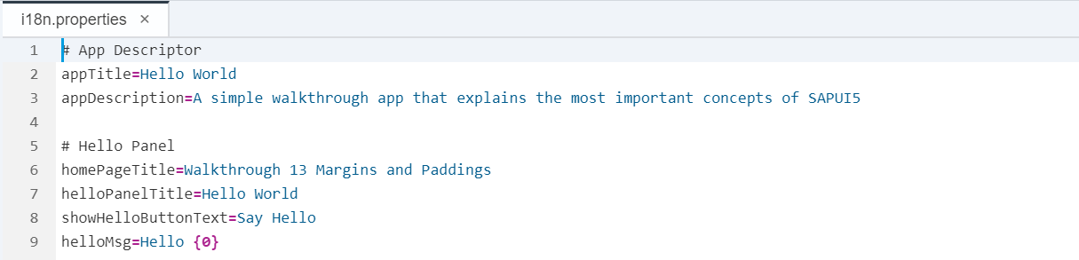

View

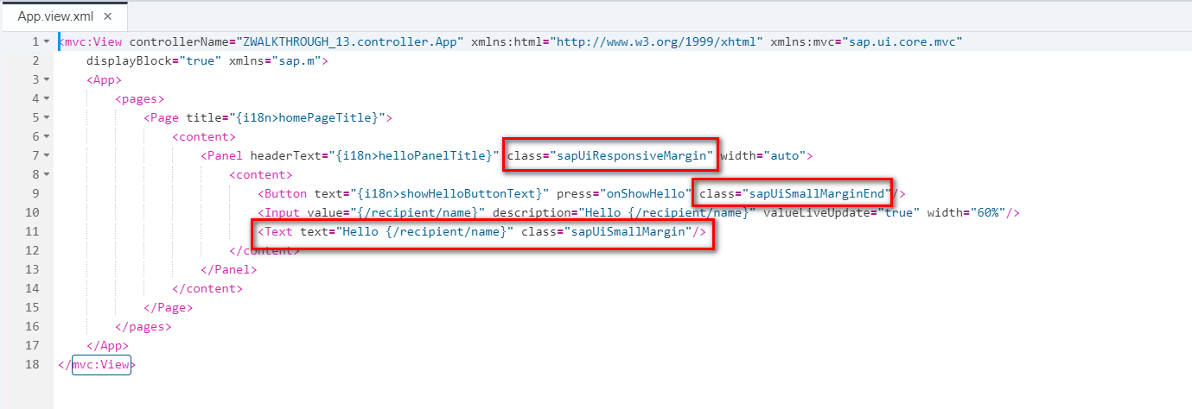

Result:

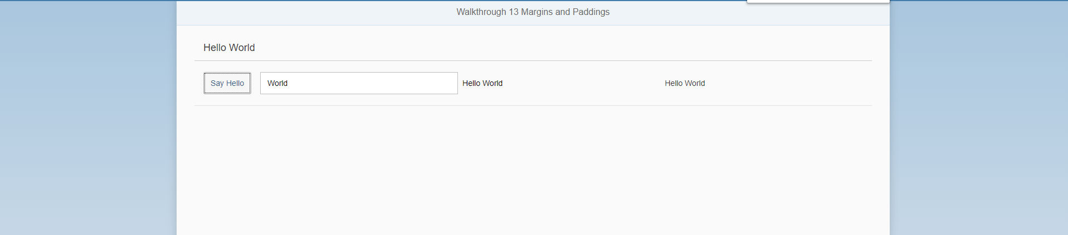

Git:

WALKTHROUGH_13

2018/11/02 XiaoMi Beijing Zac,Xie